Microprocessor Lab->2

PROGRAME FOR ADDITION OF TWO 8 BIT NUMBERS USING 8085 SIMULATOR

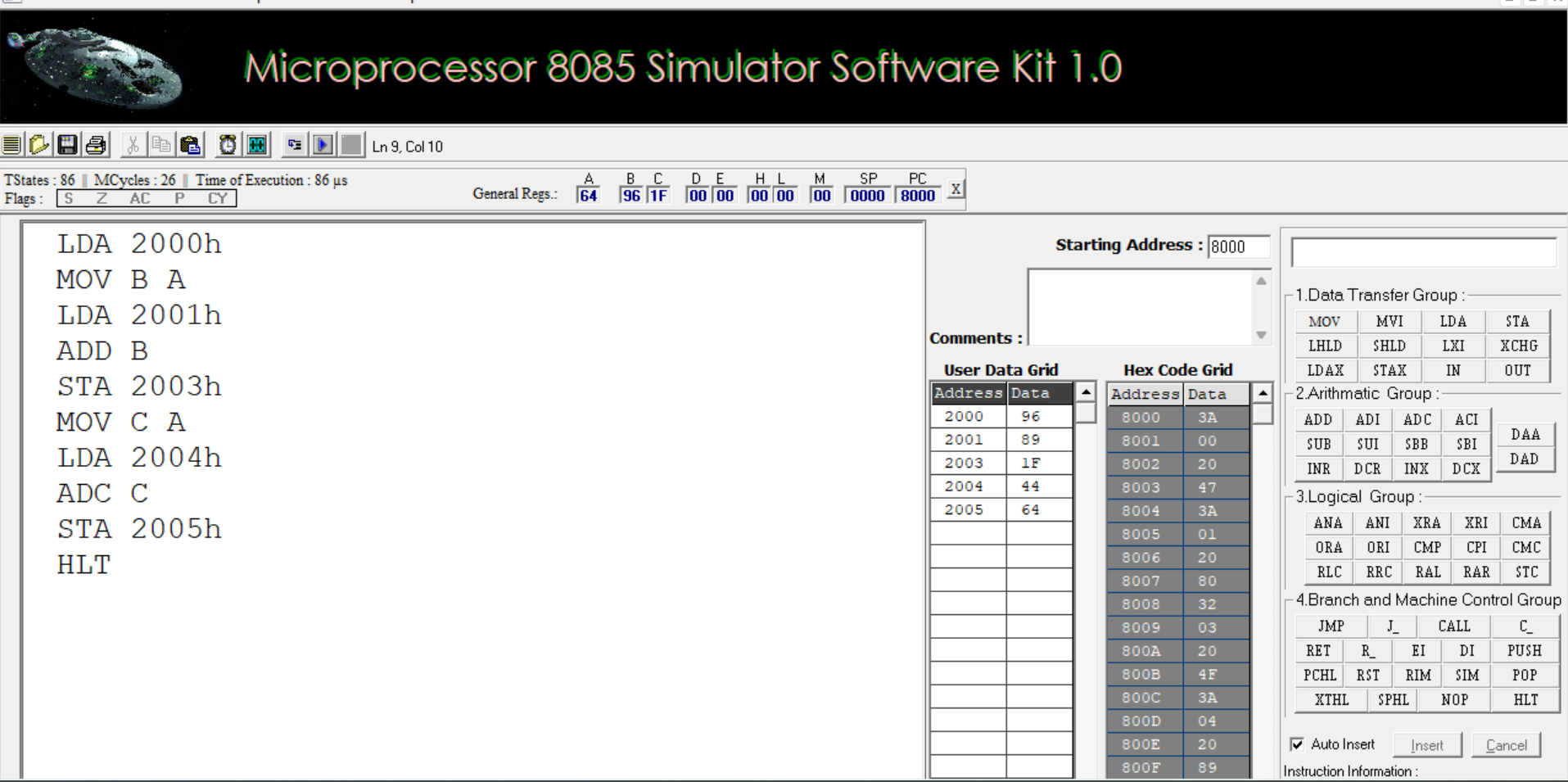

**PROGRAME FOR SUBTRACTION OF TWO 8-BIT NUMBER USING 8085 SIMULATOR**

